# Add MSIX image to host pool

This article requires all steps in the [this](https://github.com/stgeorgi/msixappattach/blob/master/documentation/Upload%20MSIX%20package%20to%20files%20share.docx) article to be completed. Once steps are completed you can proceed.

# Obtain MSIX image path

Open storage account that contains the MSIX share.

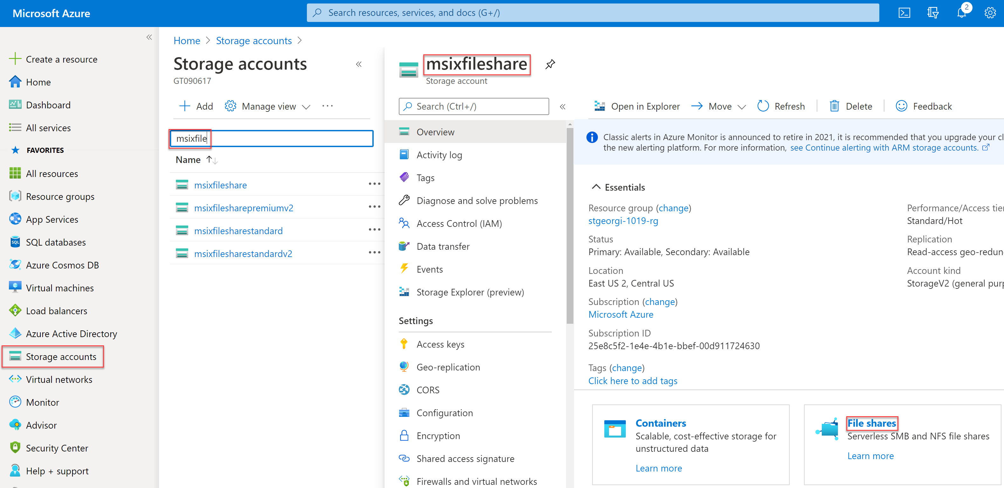

Select the file share and click **Properties**

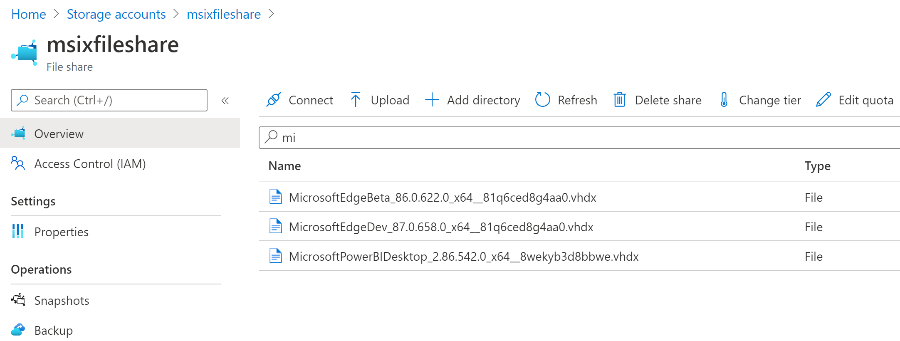

Take the URL path and convert it to UNC path

1. Replace https:// with \\
2. Replace / with \

**Example**: Starting with this URL, <https://msixfileshare.file.core.windows.net/msixfileshare> it will look like \\msixfileshare.file.core.windows.net\msixfileshare as UNC path.

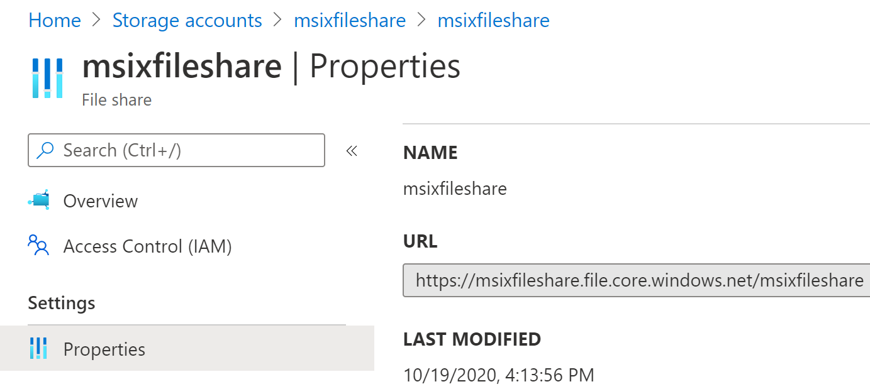

1. To UNC path append the file name and extension to get the full path to the MSIX image

**Example**: Starting with this UNC path \\msixfileshare.file.core.windows.net\msixfileshare as and file name MicrosoftEdgeBeta_86.0.622.0_x64__81q6ced8g4aa0.vhdx the path to that MSIX image will look like \\msixfileshare.file.core.windows.net\msixfileshare\MicrosoftEdgeBeta_86.0.622.0_x64__81q6ced8g4aa0.vhdx

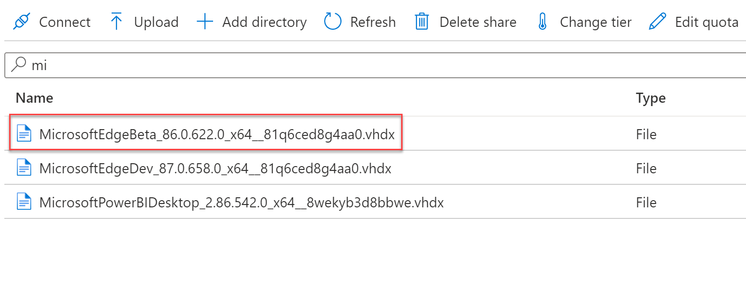

# Add MSIX image

Open Windows Virtual Desktop module

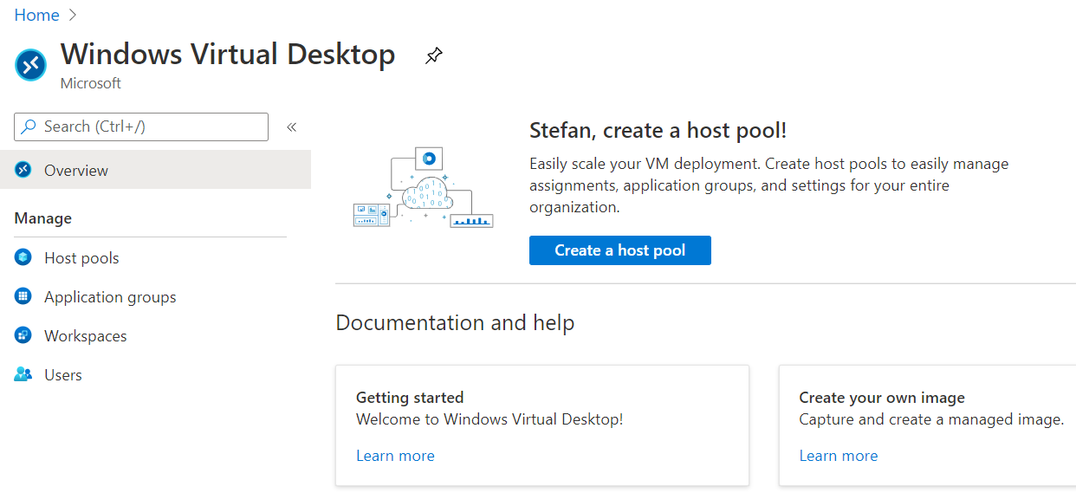

Select a host pool.

Confirm host pool has healthy VMs that are turned on.

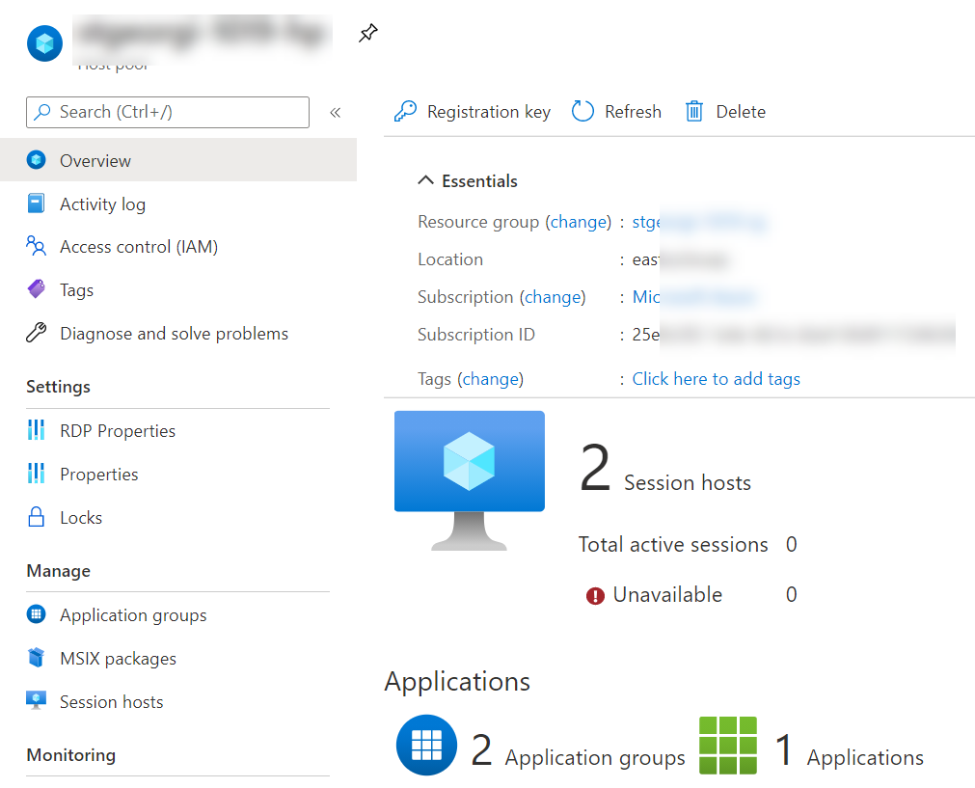

Click the **MSIX packages** tab and then select **Add.**

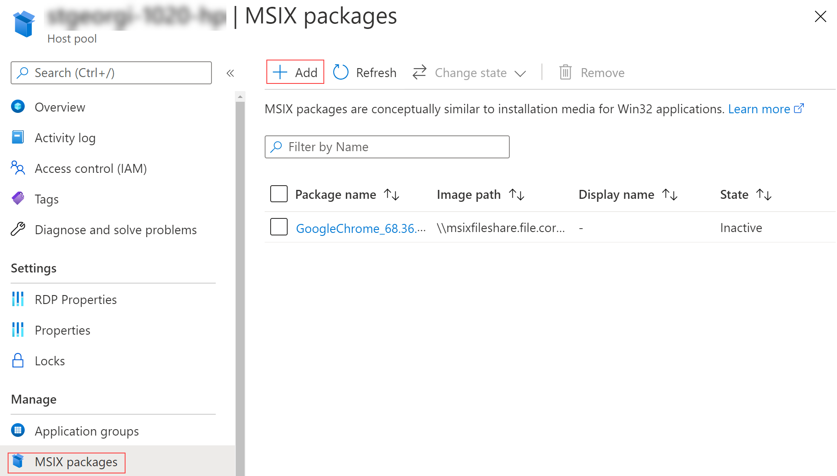

This will open **Add MSIX package**

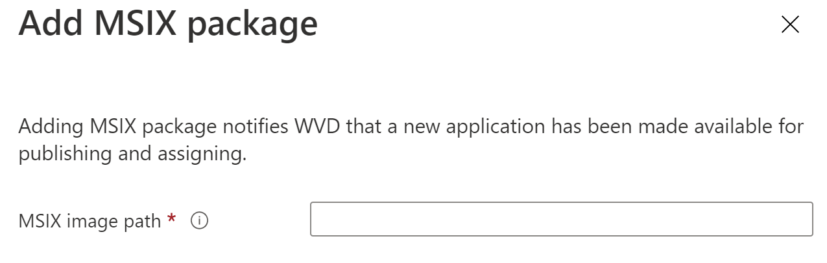

Enter the UNC path to the UNC path to the MSIX image (as prepared, in the previous section **Obtain MSIX image**)

**Example:** \\msixfileshare.file.core.windows.net\msixfileshare\MicrosoftEdgeBeta_86.0.622.0_x64__81q6ced8g4aa0.vhdx

Click the **Add** button. This will trigger a request to the RD Agent on a randomly selected healthy VM in the host pool. The request will ask the RD Agent to access the UNC path and load the MSIX image. Upon successful loading, parsing, and validation of the MSIX image and the MSIX packages stored inside. Following screen will appear.

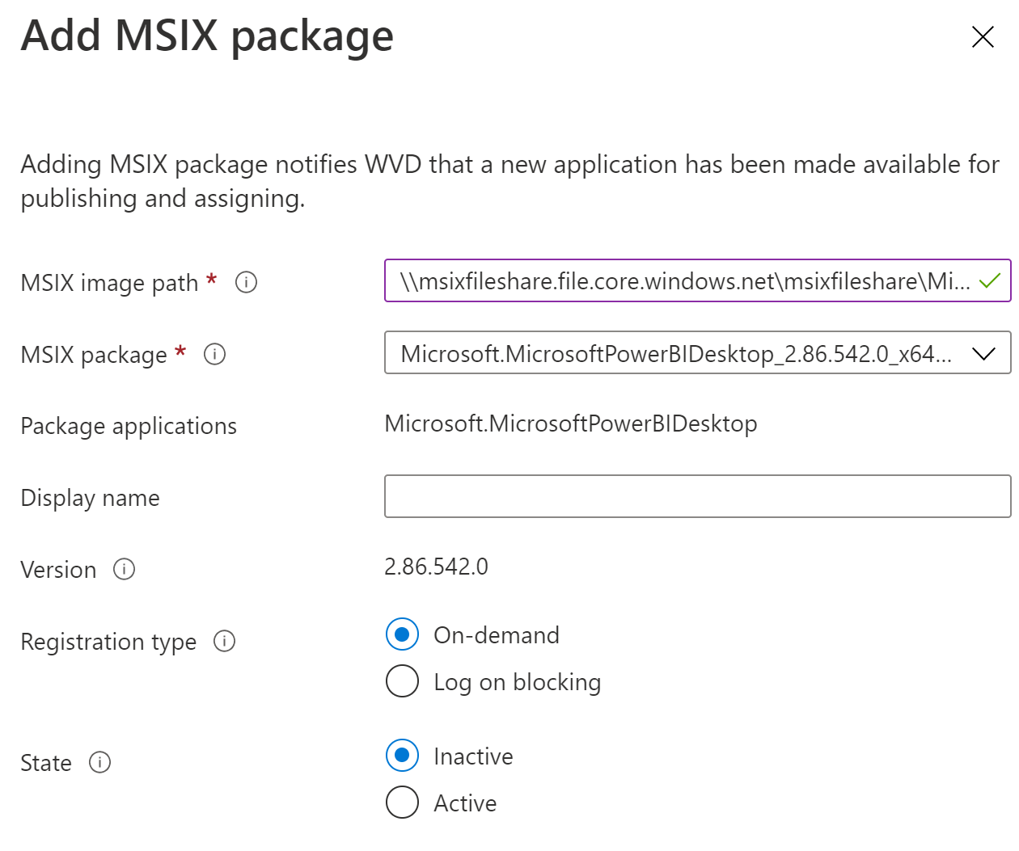

Select an MSIX package from the drop down **MSIX package**.

This will populate:

* Version
* Registration type: select **Log on blocking**
* State: set to **Active**

Click **Add.** Make sure that the package shows up in the MSIX packages grid.

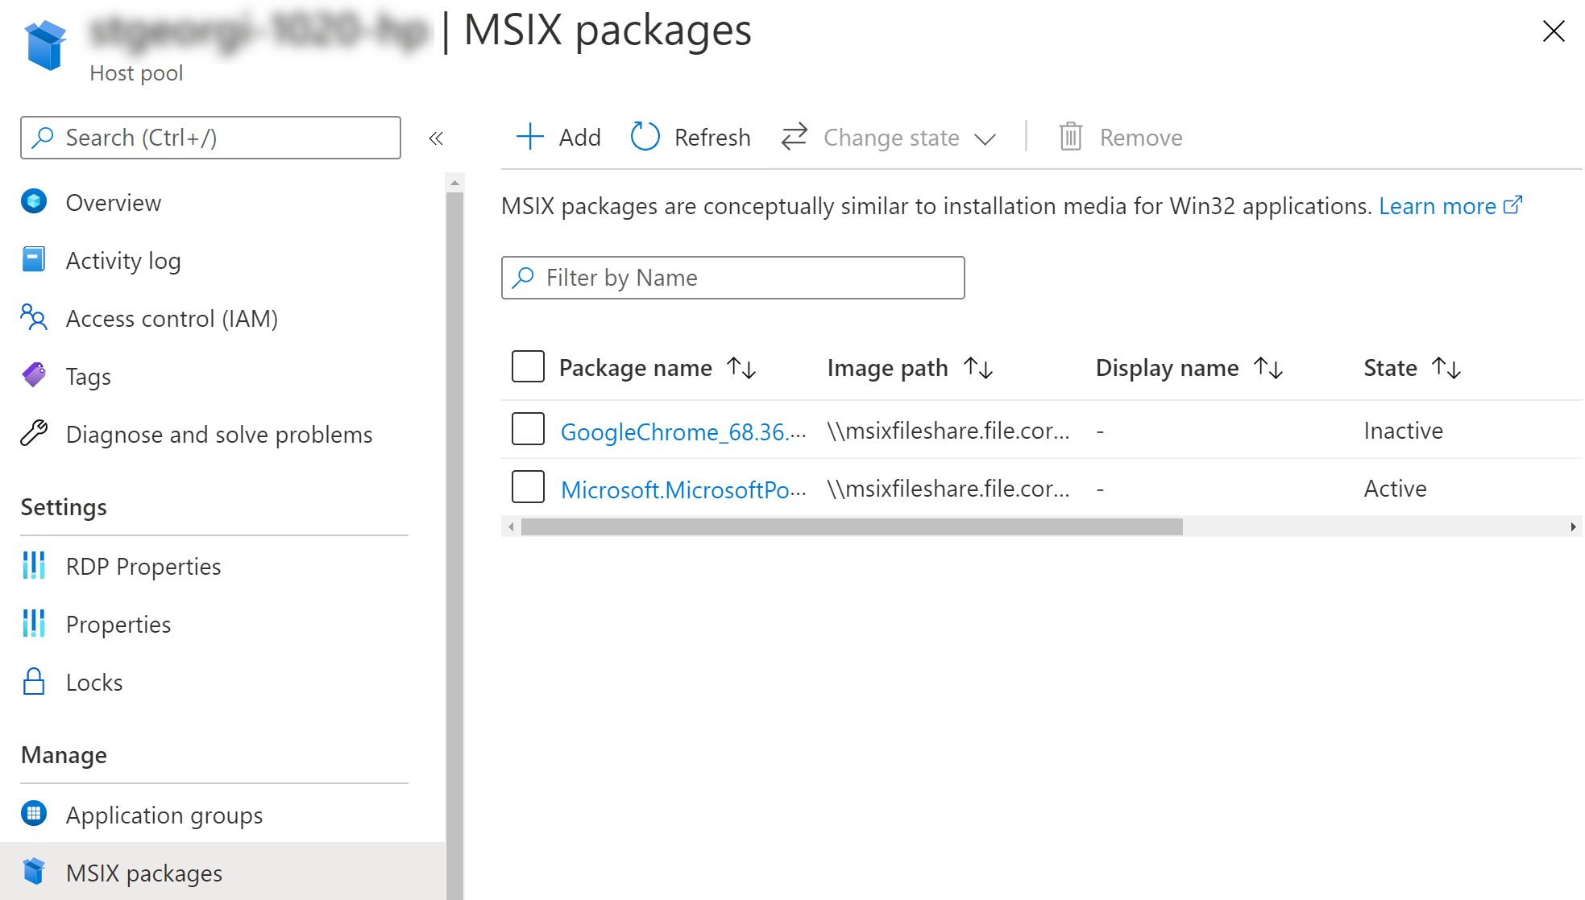

Next step Publish MSIX application to desktop application group (DAG) [here](https://microsoft-my.sharepoint-df.com/:w:/p/stgeorgi/EXPLEUihqLZCgAXuZT7QXlwB--ulo-00t1nbIY7ZhKzvhA?e=0JpZeF).